Disclaimer
- This spreadsheet is for use by qualified personal only
- All rigging loads applied to Apex stages should be reviewed by an Apex technician prior to deployment.
- All rigging attachment to structure must be done per manufacturer specifications using overhead rated rigging equipment.
- All complex rigging plans or any rigging plans within 10% of allowed maximums should be reviewed by an Engineer prior to deployment.
- This spreadsheet calculates vertical loads only. Rigging of loads that are subject to wind loading (Ex. Backdrops, scenic elements, and video walls etc..) need to be reviewed by an Engineer for horizontal forces induced.
- In all cases High Wind Action Plans (HWP) are in effect while stage is in use.

Usage Notes
The Apex Rigging spreadsheet is a complex spreadsheet that uses macros and Visual Basic (VB) scripts. This spreadsheet will only work in Microsoft Excel (NOT Apple Numbers, Google sheets or other spreadsheet programs). Compatibility with Excel on mobile devices is also unlikely to work.

Macros and VB scripts can contain viruses and Microsoft makes it difficult to run these functions. Specific steps must be taken to allow the macros and VB scripts to run correctly.

Trusted Locations
In order for this spreadsheet to function properly it must be opened from a “Trusted Location” so all macros and VB Scripts are allowed to run properly. Trusted Locations are essentially a folder on your system excel believes contains safe (virus/malware free) files and will allow these files to open from without warnings, or limited functionality.

Create a “Trusted Location”
- Create a folder wherever you would like to save these files on your system.
  - Example: Create a folder on your desktop called “Apex Rigging Calc”
- Open Excel (without a file, just click the program icon).
- Add the folder created in Step 1 above to Excel as a trusted location.
  - Navigate to Excel Options File->Options->Trust Center->Trust Center Settings->Trusted Locations
  - Click the “Add new location” button and select the folder where you are storing the file.
  - You can add multiple folder locations if you choose to. Your “desktop” is a handy folder to add.
- Copy the Apex Rigging spreadsheet into the trusted folder.
- Unblock the file if it was downloaded from the web (See instructions below)
- Open your file from the “Trusted Location” folder

Trusted Location
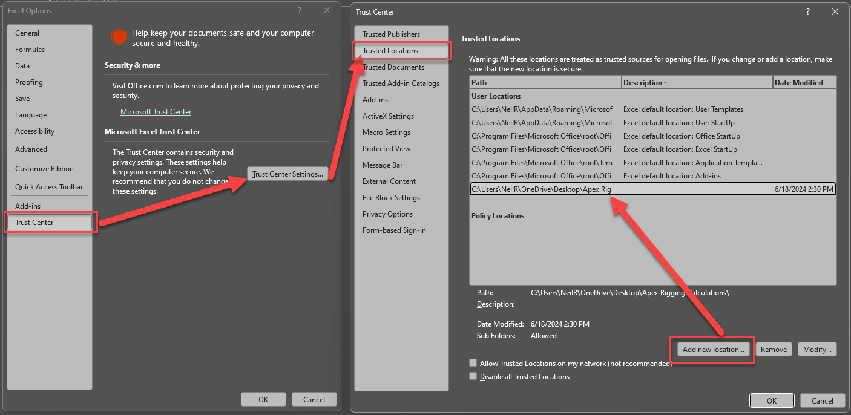

Unblocking the File
If a file is transmitted via email or downloaded it can potentially get tagged as “from the web” and may need to be unblocked before it can be used.

After you move the file to your trusted location
- Right click on the file and select properties.
- Check the “Unblock” checkbox and click ok.
